Using Microscopes

1. Label the parts of the microscope below.

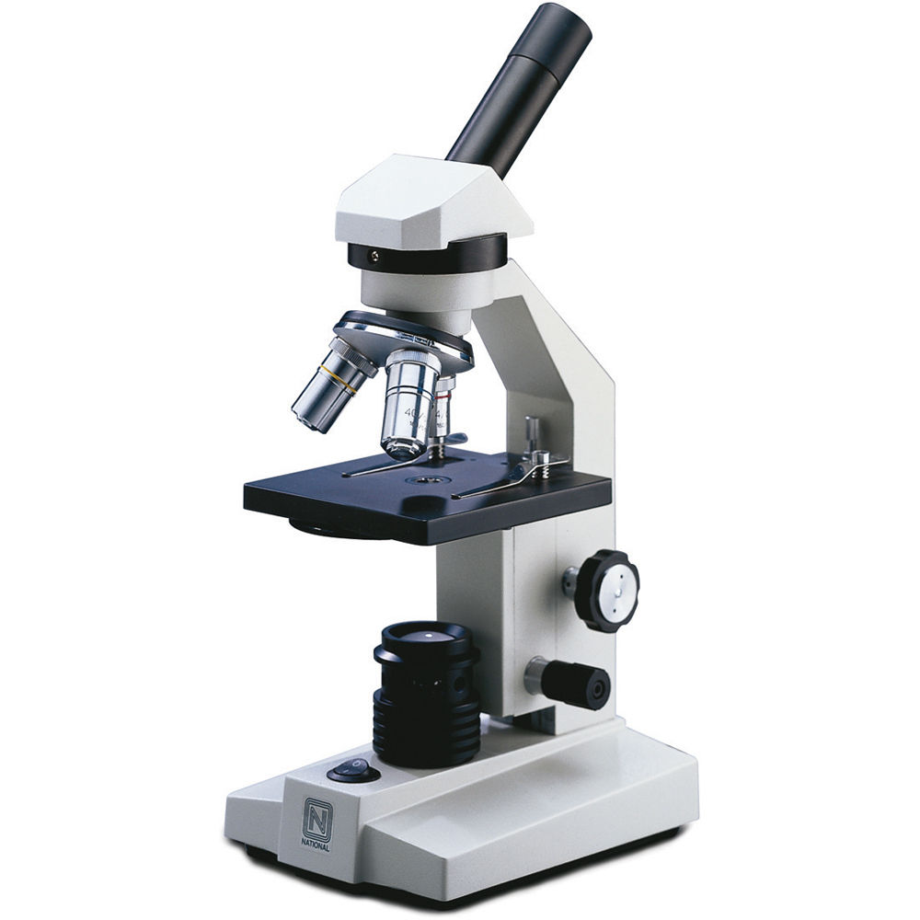

Word Bank: Stage, light, eyepiece lens, arm, coarse focus, objective lens, fine focus, base

1. For each part of the microscope, describe its function.

|  |  |
| --- | --- |
| **Part** | **Function** |
| Eyepiece lens |  |
| Objective lens |  |
| Stage |  |
| Light |  |
| Coarse focus |  |
| Fine focus |  |
| Arm |  |
| Base |  |

1. Put the steps for using a microscope in the correct order.

|  |  |
| --- | --- |
|  | Lower the stage and put the slide on it. |
|  | Look through the eyepiece lens and turn the coarse focus knob until you see an image |
|  | Place the microscope on a flat surface. |
|  | Use the fine focus knob to sharpen the image |
|  | Looking from the side, raise the stage to the top |
|  | Carry the microscope with two hands. |
|  | Make sure the smallest objective lens is in place. |

1. Identify two things you need to do to handle a microscope correctly.
   1. ____________________________________________________________
   2. ____________________________________________________________
2. Complete the sentences below by circling the correct choice:
   1. When first examining a slide use the **smallest / largest** lens.
   2. When focussing, only move the stage **towards / away** from the lens.
   3. When changing to a larger lens, always look from **the side / above** to make sure the **eyepiece / objective** lens doesn’t touch the slide.
   4. Use the **coarse / fine** focus knob to find the image, the use the **coarse / fine** focus to sharpen the image.